U25AI055
DSA Lab-9
PART 1 :
- Given two arrays a[] and b[] of size m and n respectively, the task is to determine whether b[] is a subset of a[]. Both arrays are not sorted, and elements are distinct. Input: a[] = [11, 1, 13, 21, 3, 7], b[] = [11, 3, 7, 1] Output: true
#include<iostream>
using namespace std;
int main()
{
int m, n;
cout<<"Enter m ";
cin>>m;
cout<<"Enter n ";
cin>>n;
int a[m], b[n];
cout<<"Enter A elements ";
for(int i=0; i<m; i++)
cin>>a[i];
cout<<"Enter B elements ";
for(int i=0; i<n; i++)
cin>>b[i];
int j;
for(j=0; j<n; j++)
{
bool flag=false;
for(int i=0; i<m && !flag; i++)
{
if(a[i]==b[j])
flag=true;
}
if(!flag)
break;
}
if(j==n)
cout<<"B subset of A\n";
else
cout<<"B not subset of A\n";
return 0;
}
Output :
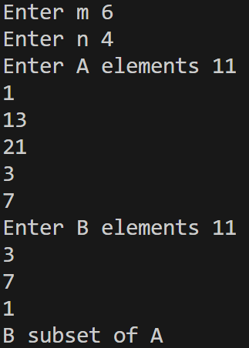
- Given an array arr[], the task is to find the maximum distance between two occurrences of any element. If no element occurs twice, return 0. Input: arr = [1, 1, 2, 2, 2, 1] Output: 5 Explanation: distance for 1 is: 5-0 = 5, distance for 2 is: 4-2 = 2, So max distance is 5.
#include<iostream>
using namespace std;
int main()
{
int n;
cout<<"Enter number of elements ";
cin>>n;
int arr[n];
cout<<"Enter elements ";
for(int i=0; i<n; i++)
cin>>arr[i];
int max=0;
for(int i=0; i<=n-2; i++)
{
for(int j=i+1; j<=n-1; j++)
{
if(arr[i]==arr[j] && j-i>max)
max=j-i;
}
}
cout<<"Maximum difference between two occurences of elements="<<max<<endl;
return 0;
}
Output :
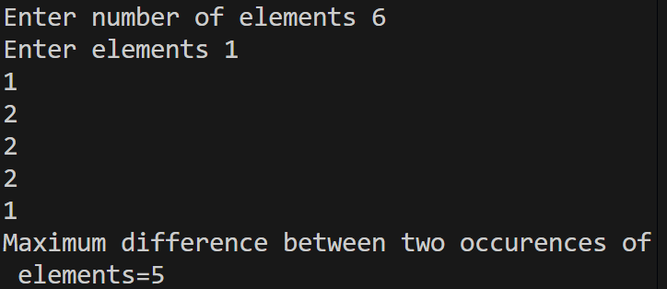
- Given two arrays a[] and b[], find their intersection — the unique elements that appear in both. Ignore duplicates, and the result can be in any order. Input: a[] = [1, 2, 1, 3, 1], b[] = [3, 1, 3, 4, 1] Output: [1, 3] Explanation: 1 and 3 are the only common elements and we need to print only one occurrence of common elements
#include<iostream>
#include<vector>
using namespace std;
void sort_array(int arr[], int n);
int main()
{
int m, n;
cout<<"Enter m ";
cin>>m;
cout<<"Enter n ";
cin>>n;
int a[m], b[n];
cout<<"Enter 1st array elements ";
for(int i=0; i<m; i++)
cin>>a[i];
cout<<"Enter 2nd array elements ";
for(int i=0; i<n; i++)
cin>>b[i];
sort_array(a, m);
sort_array(b, n);
int arr[(m>n) ? m : n], count=0;
for(int i=0, j=0; i<m && j<n;)
{
if(a[i]==b[j])
{
arr[count++]=a[i];
i++;
j++;
}
else if(a[i]<b[j])
i++;
else
j++;
}
for(int i=0; i<count; i++)
cout<<arr[i]<<"\t";
return 0;
}
void sort_array(int arr[], int n)
{
for(int pass=1; pass<=n-1; pass++)
{
for(int i=0; i<pass-i; i++)
{
if(arr[i]>arr[i+1])
{
int temp=arr[i];
arr[i]=arr[i+1];
arr[i+1]=temp;
}
}
}
}
Output :
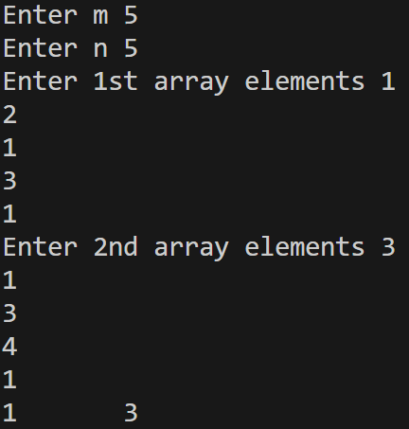
- Given an array arr[] of n integers and a target value, find the number of pairs of integers in the array whose sum is equal to target. Input: arr[] = [1, 5, 7, -1, 5], target = 6 Output: 3 Explanation: Pairs with sum 6 are (1, 5), (7, -1) & (1, 5).
#include<iostream>
#include<vector>
using namespace std;
int find_pairs(int arr[], int n, int target);
int main()
{
int n, target;
cout<<"Enter number of elements ";
cin>>n;
int arr[n];
cout<<"Enter elements ";
for(int i=0; i<n; i++)
cin>>arr[i];
cout<<"Enter target ";
cin>>target;
cout<<"Number of pairs="<<find_pairs(arr, n, target)<<endl;
return 0;
}
int find_pairs(int arr[], int n, int target)
{
int count=0;
for(int i=0; i<=n-2; i++)
{
for(int j=i+1; j<=n-1; j++)
{
if(arr[i]+arr[j]==target)
count++;
}
}
return count;
}
Output :
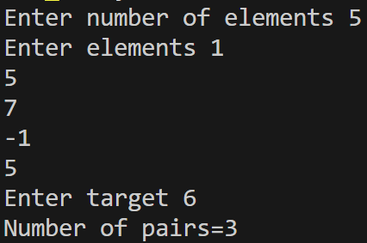
PART 2 :
- Implementation of Hash Table (Division Method)
//Implementation of hash table (Division method)
#include<iostream>
using namespace std;
struct Node
{
int data;
Node *next;
};
int main()
{
int m, n;
cout<<"Enter m ";
cin>>m;
Node *table[m];
for(int i=0; i<m; i++)
table[i]=NULL;
cout<<"Enter number of keys ";
cin>>n;
int keys[n];
cout<<"Enter keys ";
for(int i=0; i<n; i++)
cin>>keys[i];
for(int i=0; i<n; i++)
{
int j=keys[i]%m;
Node *new_node;
new_node=new Node;
new_node->data=keys[i];
new_node->next=NULL;
if(table[j]==NULL)
table[j]=new_node;
else
{
new_node->next=table[j];
table[j]=new_node;
}
}
for(int i=0; i<m; i++)
{
Node *p;
p=table[i];
cout<<"Cell="<<i<<"\t";
while(p!=NULL)
{
cout<<p->data<<"->";
p=p->next;
}
cout<<endl;
}
return 0;
}
Output :
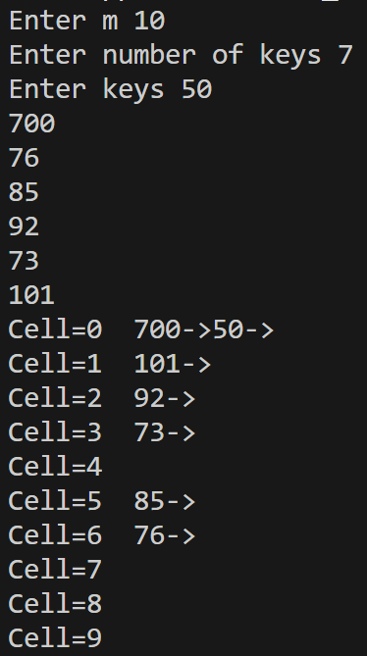
- Multiplication Hash Function
//Multiplication hash function
#include<iostream>
#include<math.h>
using namespace std;
struct Node
{
int data;
Node *next;
};
int main()
{
int m, n;
cout<<"Enter m ";
cin>>m;
Node *table[m];
for(int i=0; i<m; i++)
table[i]=NULL;
cout<<"Enter number of keys ";
cin>>n;
int keys[n];
cout<<"Enter keys ";
for(int i=0; i<n; i++)
cin>>keys[i];
const float A=(sqrt(5)-1)/2;
for(int i=0; i<n; i++)
{
int j=(int)(m*(keys[i]*A-floor(keys[i]*A)));
Node *new_node;
new_node=new Node;
new_node->data=keys[i];
new_node->next=NULL;
if(table[j]==NULL)
table[j]=new_node;
else
{
new_node->next=table[j];
table[j]=new_node;
}
}
for(int i=0; i<m; i++)
{
cout<<"Cell="<<i<<"\t";
Node *p;
p=table[i];
while(p!=NULL)
{
cout<<p->data<<"->";
p=p->next;
}
cout<<endl;
}
return 0;
}
Output :
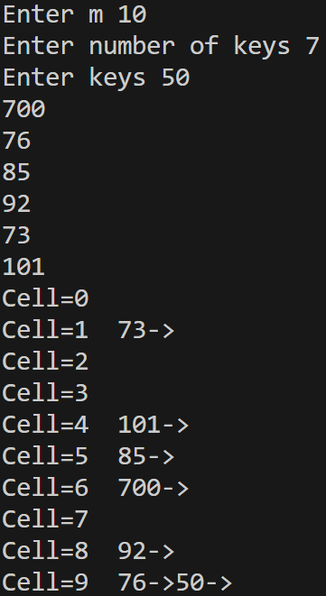
- Mid-Square and Folding Methods
//Mid-square method
#include<iostream>
#include<math.h>
using namespace std;
struct Node
{
int data;
Node *next;
};
int count_digits(int num);
int main()
{
int n;
Node *table[100];
for(int i=0; i<100; i++)
table[i]=NULL;
cout<<"Enter n ";
cin>>n;
int keys[n];
cout<<"Enter keys ";
for(int i=0; i<n; i++)
cin>>keys[i];
for(int i=0; i<n; i++)
{
int square=keys[i]*keys[i], count=count_digits(square);
float remove=(count-2)/2;
int middle=((int)(square/pow(10, remove)))%(int)pow(10, 2);
int j=middle%100;
Node *new_node;
new_node=new Node;
new_node->data=keys[i];
new_node->next=NULL;
if(table[j]==NULL)
table[j]=new_node;
else
{
new_node->next=table[j];
table[j]=new_node;
}
}
for(int i=0; i<100; i++)
{
Node *p;
p=table[i];
cout<<"Cell="<<i<<"\t";
while(p!=NULL)
{
cout<<p->data<<"->";
p=p->next;
}
cout<<endl;
}
return 0;
}
int count_digits(int num)
{
int count=0;
while(num>0)
{
count++;
num/=10;
}
return count;
}
Output :
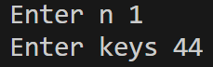
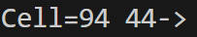
- Collision Resolution Using Linear Probing
//Linear probing
#include<iostream>
using namespace std;
int main()
{
int m, n;
cout<<"Enter m ";
cin>>m;
int table[m];
for(int i=0; i<m; i++)
table[i]=-1;
cout<<"Enter number of keys ";
cin>>n;
int keys[n];
cout<<"Enter keys ";
for(int i=0; i<n; i++)
cin>>keys[i];
for(int j=0; j<n; j++)
{
int i=0, k;
do
{
k=(keys[j]+i)%m;
if(table[k]!=-1)
i++;
}while(table[k]!=-1 && i<=5);
if(table[k]==-1)
table[k]=keys[j];
}
for(int i=0; i<m; i++)
cout<<"Cell="<<i<<"\t"<<table[i]<<endl;
return 0;
}
Output :
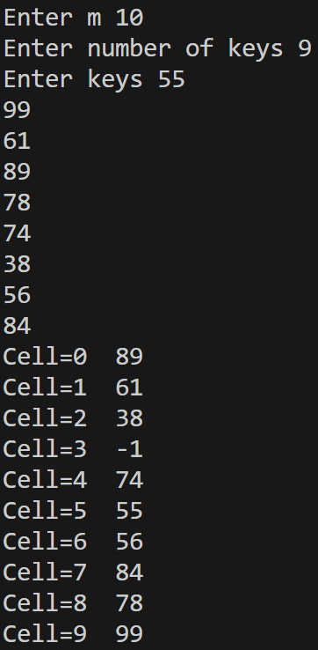
- Collision Resolution Using Quadratic Probing
//Quadratic probing
#include<iostream>
using namespace std;
int main()
{
int m, n;
cout<<"Enter m ";
cin>>m;
int table[m];
for(int i=0; i<m; i++)
table[i]=-1;
cout<<"Enter number of keys ";
cin>>n;
int keys[n];
cout<<"Enter keys ";
for(int i=0; i<n; i++)
cin>>keys[i];
for(int j=0; j<n; j++)
{
int i=0, k;
do
{
k=(keys[j]+i*i)%m;
if(table[k]!=-1)
i++;
}while(table[k]!=-1 && i<=5);
if(table[k]==-1)
table[k]=keys[j];
}
for(int i=0; i<m; i++)
cout<<"Cell="<<i<<"\t"<<table[i]<<endl;
return 0;
}
Output :
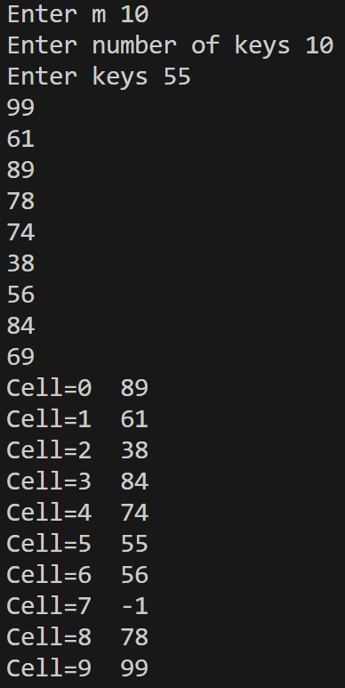
- Collision Resolution Using Double Hashing
//Double hashing
#include<iostream>
using namespace std;
int main()
{
int m, n;
cout<<"Enter m ";
cin>>m;
int table[m];
for(int i=0; i<m; i++)
table[i]=-1;
cout<<"Enter number of keys ";
cin>>n;
int keys[n];
cout<<"Enter keys ";
for(int i=0; i<n; i++)
cin>>keys[i];
for(int j=0; j<n; j++)
{
int i=0, k;
do
{
k=(keys[j]%m+i*((1+keys[j])%(m-2)))%m;
if(table[k]!=-1)
i++;
}while(table[k]!=-1 && i<=5);
if(table[k]==-1)
table[k]=keys[j];
}
for(int i=0; i<m; i++)
cout<<"Cell="<<i<<"\t"<<table[i]<<endl;
return 0;
}
Output :
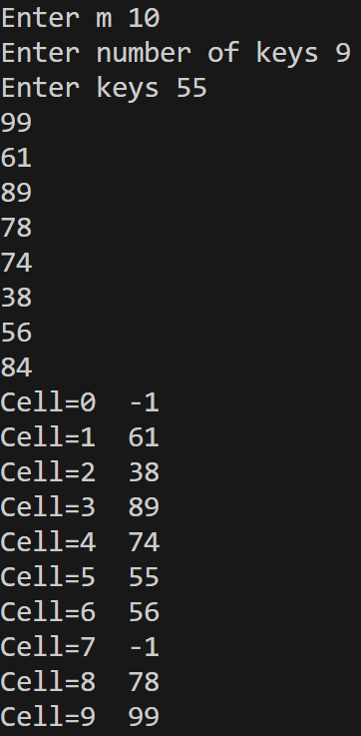
- Collision Resolution Using Chaining
//Chaining
#include<iostream>
using namespace std;
struct Node
{
int data;
Node *next;
};
int main()
{
int m, n;
cout<<"Enter m ";
cin>>m;
Node *table[m];
for(int i=0; i<m; i++)
table[i]=NULL;
cout<<"Enter number of keys ";
cin>>n;
int keys[n];
cout<<"Enter keys ";
for(int i=0; i<n; i++)
cin>>keys[i];
for(int i=0; i<n; i++)
{
int j=keys[i]%m;
Node *new_node;
new_node=new Node;
new_node->data=keys[i];
new_node->next=NULL;
if(table[j]==NULL)
table[j]=new_node;
else
{
new_node->next=table[j];
table[j]=new_node;
}
}
for(int i=0; i<m; i++)
{
Node *p;
p=table[i];
cout<<"Cell="<<i<<"\t";
while(p!=NULL)
{
cout<<p->data<<"->";
p=p->next;
}
cout<<endl;
}
return 0;
}
Output :


